Welcome to Glen
Pre-Induction Letter
Employee Support
Glen Group Limited
Unit A1 Merak House
Fourth Way
Bristol
08081754358
Email: EmployeeSupport@glengroupltd.com

Dear (insert name) Date:

Welcome to Glen and thank you for choosing to come and work with us.

Your induction programme has been designed to help you settle quickly into your new position, by giving you the information, training, and support for your role with Glen.

To make the on-boarding process as smooth as possible, we have enclosed the link to the following documents and training videos that we ask you to view before your induction day to give you an overview of the induction process:

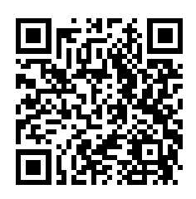
- Offer of Employment
- Job Description
- Time & Attendance Pinning
- Pay Date Information
- Glen Induction Video
- Cleaning Methods and Tasks

- All of the above can be obtained by clicking on this Link Welcome to Glen
Alternatively, you can scan the QR Code

On your induction day, please remember to bring with you your Right to Work documents for us to check during your induction – we have attached the Right to Work Document Checklist to confirm which documents are accepted.

Your Induction will take place at………………………………On…………………………….

We look forward to meeting you soon and welcoming you as part of the Glen Family.

If you have any questions, please email us at employeesupport@glengroupltd.com
.

Kind regards,

